Interest in Student Teaching Abroad
Name: | Major: | Student ID:
E-mail: | Phone Number: | Semester and Year:
Please indicate your 1st and 2nd choice by marking [1] or [2] next to your country of interest,
and either email it directly to Dr. Richey, or drop it under the office door in KH 3202.

New Site! Madrid [ ] P-12 Costa Rica [ ] P-12
[ ] P-8
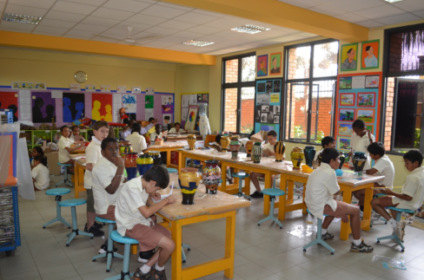

Ecuador [ ] P-12 Trinidad and Tobago [ ] P-12 Uganda [ ] P-12
